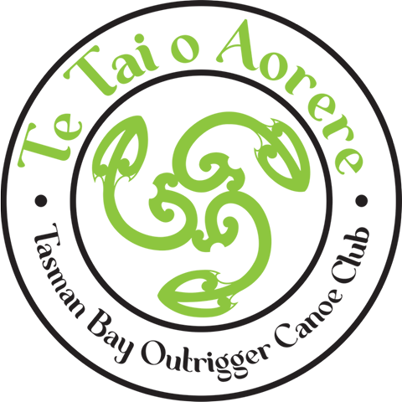
Hoe Matariki
Tahunanui Beach
Nelson
Panui#2
Please drop waka off in the Abel Tasman Carpark and take down onto the beach to the west side of the Moana Sup container. Waka will be ok above the high tide line over night if you are using on Friday and Saturday. Trailers can then be moved to the carpark at the Nelson Marina on Akersten Street. We are not closing the carpark but there is ample (free) parking in the area. You are also welcome to unload and paddle your waka from the Nelson Marina.
There are changing/ toilet facilities close by.
The best coffee shop in town is located across the road. Shane at Raglan Roast is generously offering one free regular coffee to all adult entrants. Your voucher will be in your race pack for collection at the Ray White Real Estate registration tent – That should start your day nicely but don’t be afraid to cross the road several times a day for that coffee hit!

We have some amazing Spot prizes which will be drawn at the conclusion of racing on Saturday including
A 1:1 training session with Tupu King - either via zoom or in person on his next trip to Nelson
2 half day Ebike hires from The Gentle Cycle Company
Kayak HQ vouchers
Vaa Factory goodies
But wait theres more……

Thank you to our sponsors ………….
